CHAPTER 2
BACKGROUND THEORY

2.1. Fundamental of Linux
Linux is a family of free and open-source software operation systems built around the Linux kernel. Typically, Linux is packaged in a from known as a Linux distribution (or distro for short) for both desktop and server use. The defining component of a Linux distribution is the Linux kernel, an operation system kernel first released on September 17 , 1991 , by LIUNX TORVALDS.
Many Linux distributions use the word “Linux” in their name. The Free Software uses the name GNU/Linux to refer to the operation system family, as well as specific distributions,
To emphasize that most Linux distribution are not just the Linux kernel, and that they have in common not only the kernel, but also numerous utilities and libraries, a large proportion of which are from the GNU project.
The primary difference between Linux and many other popular contemporary operating systems is that the Linux kernel and other components are free and open-source software. Linux is not the only such operating system, although it is by far the most widely used.
Some free and open-source software licenses are based on the principle of copyleft. The most common free software license, the GNU General Public License (GPL). Besides the Linux distributions designed for general-purpose use on desktops and servers, distributions may be specialized for different purposes including: computer architecture support, embedded systems, stability, security, localization to a specific region or language, targeting of specific user groups, support for real-time applications, or commitment to a given desktop environment.
Furthermore, some distributions deliberately include only free software. As of 2018, about five hundred Linux distributions are actively developed, with about a dozen distributions being most popular for general-purpose use. Linux has the largest installed base of all general-purpose operating system. Linux is also the leading
operating system on servers and other big iron system such as mainframe computers and the only OS used on TOP 500 supercomputers. It is used by around 2.3% of desktop computers.
Torvalds continues to direct the development of the kernel. Stallman heads the Free Software Foundation, which in turn supports the GNU components. Finally, individuals and corporations develop third-party non-GNU components. These third-party components comprise a vast body of work and may include both kernel modules and user applications and libraries.
The development of Linux is one of the most prominent examples of free and open-source software collaboration. The underlying source code may be used, modified and distributed-commercially or non-commercially-by anyone under the terms of its respective licenses, such as the GNU General Public License. [2]
Some of the most popular and mainstream Linux distribution are Debian family (Debian , Ubuntu , Kali , Ubuntu Mint and so on ) , Fedora family ( fedora , RHEL , CentOS and so on ) and SUSE family ( SUSE , OpenSUSE ) as shown in figure 2.1.

Figure 2.1 Linux Distro Flow Chart

The highlighted Linux OS in above figure 1.1 , CentOS and Ubuntu were used in this thesis as these two are the most useful and popular ones. CentOS is included under fedora family and ubuntu under Debian family The details of them were explained below.
2.1.1. Key Facts About The Fedora Family
- The Fedora Family is upstream for CentOS , REHL and Fedora.
- Kernel Version 3.10 is used in CentOS/RHEL.
- It used the RPM-based yum package manage to install , update and remove packages in the system
- RHEL is widely used by enterprises which host their own system.
- Fedora Family Flow shown in figure 2.2.

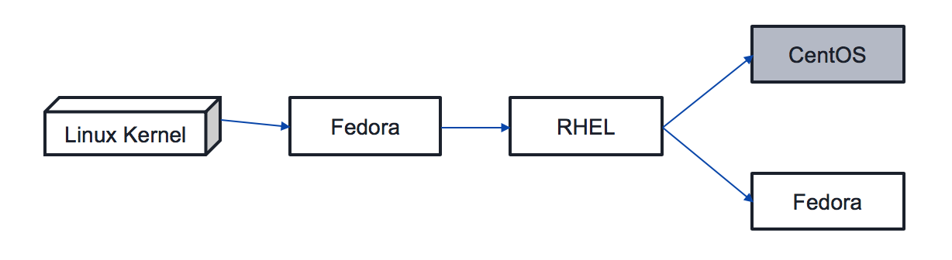
Figure 2.2 Fedora Family Flow

2.1.1.1. CentOS
CentOS (Community Enterprise Operating System ) is a Linux distribution that provide a free, enterprise-class, community-supported computing platform functionally compatible with its upstream source, Red Hat Enterprise Linux (RHEL). In January 2014, CentOS announced the official joining with Red Hat while staying independent from RHEL, under a new CentOS governing board.
The first CentOS release in May 2004, numbered as CentOS version 2, was forked from RHEL version 2.1AS. Since the release of version 7.0, CentOS officially supports only the x86-64 architecture, while versions older than 7.0-1406 also support IA-32 with Physical Address Extension (PAE). As of December 2015, AltArch releases of CentOS 7 are available for the IA-32 architecture. The highlighted Linux OS in above figure 2.2 , CentOS was used in this thesis.
CentOS version numbers for releases older than 7.0 have two parts, a major version and a minor version, which correspond to the major version and update set of Red Hat Enterprise Linux (RHEL) used to build a particular CentOS release. For example, CentOS 6.5 is built from the source packages of RHEL 6 update 5 (also known as RHEL version 6.5), which is a so-called "point release" of RHEL 6.[3]
2.1.2. Key Facts About The Debian Family
- The Debian family is upstream for Kali , Ubuntu and Ubuntu is upstream for Linux Mint and others.
- Kernel version 4.4 is used in Ubuntu 16.04 LTS.
- It uses the DPKG-based-APT package to install , update , and remove package in the system.
- Ubuntu has been widely used for end-users.
- Debian Family Flow as shown in figure 2.3.

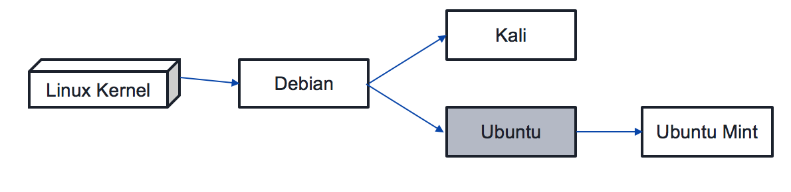
Figure 2.3 Debian Family Flow

2.1.2.1. Ubuntu
Ubuntu is a free and open source operating system and Linux distribution based on Debian. Ubuntu is offered in three official editions: Ubuntu Desktop for personal computers, Ubuntu Server for servers and the cloud and Ubuntu Core for Internet of things devices and robots. New releases of Ubuntu occur every six months, while long-term support (LTS) releases occur every two years.
Canonical provides free guaranteed security updates and support for each Ubuntu release, starting from the release date and until the release reaches its predesignated end-of-life (EOL) date. Canonical generates revenue through the sale of premium services related to Ubuntu. The highlighted Linux OS in above figure 2.4 , Ubuntu was used in this thesis.
Ubuntu's goal is to be secure "out-of-the box". By default, the user's programs run with low privileges and cannot corrupt the operating system or other users' files. For increased security, the sudo tool is used to assign temporary privileges for performing administrative tasks, which allows the root account to remain locked and helps prevent inexperienced users from inadvertently making catastrophic system changes or opening security holes.[4]
2.1.3. Common Command of Linux (Any Distribution)
The common command of Linux (any distro) described following table 2.1.

Command | Result
ls | The ls command - the list command - functions in the Linux terminal to show all of the major directories filed under a given file system
cd | The cd command - change directory - will allow the user to change between file directories
mkdir | The mkdir - make directory - command allows the user to make a new directory.
touch | The touch command - the make file command
rm | The rm command - remove - like the rmdir command is meant to remove files from Linux OS.
clear | Using the clear command will take the user back to the start prompt of whatever directory you are currently operating in.
pwd | Print the name of working directory.
man | Display the help information for the specified command.
who | Display who is logged on.
chmod | Change a file’s permissions.
chown | Change who owns a file
ssh | Remotely log in to another Linux machine, over the network.  Leave a ssh session by typing exit.
Table 2.1 List of Common Command of Linux
2.1.4. Linux Filesystem Hierarchy Standard
The Filesystem Hierarchy Standard (FHS) defines the directory structure and directory contents in Linux distributions. It is maintained by the Linux Foundation. The latest version is 3.0, released on 3 June 2015.
Most of these directories exist in all Unix-like operating systems and are generally used in much the same way; however, the descriptions here are those used specifically for the FHS, and are not considered authoritative for platforms other than Linux.

Directory | Description
/ | Primary hierarchy root and root directory of the entire file system hierarchy.
/bin | Essential command binaries that need to be available in single user mode; for all users
/var | Variable files—files whose content is expected to continually change during normal operation of the system—such as logs, spool files, and temporary e-mail files.
/boot | Boot loader files, e.g., kernels, initrd.
/dev | Essential device files, e.g., /dev/null
/etc | Host-specific system-wide configuration files
/opt | Optional application software packages
/home | Users' home directories, containing saved files, personal settings, etc.
/lib | Libraries essential for the binaries in /bin and /sbin.
/root | Home Directory for root user.
/usr | Secondary hierarchy for read-only user data; contains the majority of (multi-)user utilities and applications.
/tmp | Temporary files (see also /var/tmp). Often not preserved between system reboots, and may be severely size restricted.
Table 2.2 Filesystem Hierarchy Standard
2.2. Introduction to Server (Program)
The purpose of a server is to share data as well as to share resources and distribute work. A server computer can serve its own computer programs as well; depending on the scenario, this could be part of an exchange of services transaction, or simply a technical possibility. The following table shows several scenarios in which a server is used.
The client-server characteristic describes the relationship of cooperating programs in an application. The server component provides a function or service to one or many clients, which initiate requests for such services. Servers are classified by the services they provide. For example, a web server serves web pages and a file server serves computer files. A shared resource may be any of the server computer's software and electronic component, from programs and data to processors and storage devices. The sharing of resources of a server constitutes a service. [5]

Figure 2.4 Client-Server Architecture

Among many server programs, the common ones which are web server, database server, mail server, FTP server were used in this thesis and explained superficial in below table 2.3.
Server type | Purpose | Client
Web Server | Hosts web pages. A web server is what makes the World Wide Web possible. Each website has one or more web servers. [6] | Computers with a web browser
Database Server | Maintains and shares any form of database (organized collections of data with predefined properties that may be displayed in a table) over a network. [6] | Virtually any computer program that consumes well-organized data, especially in large volumes
Mail Server | Mail Transfer Agent (MTA) or mail relay is software that transfers electronic mail messages from one computer to another using a client–server application architecture. | Mail User Agent (MUA) is a computer program in the category of groupware environments used to access and manage a user's email.
FTP Server | It works on one of the oldest of the Internet services, the file transfer protocol. It provides a secure file transfer between computers while ensuring file security and transfer control. | Computers with a web browser or via FTP client software.

Table 2.3 List of Common Server Type and its purpose, Client

2.2.1. Web Server
Web Server refers to server software, or hardware dedicated to running said software, that can serve contents to the World Wide Web. A web server processes incoming network requests over the HTTP protocol.
Client–server systems are today most frequently implemented by (and often identified with) the request–response model: a client sends a request to the server, which performs some action and sends a response back to the client, typically with a result or acknowledgement.

Figure 2.5 Web Server

The server is part of the client–server model; in this model, a server serves data for clients. The nature of communication between a client and server is request and response. This is in contrast with peer-to-peer model in which the relationship is on-demand reciprocation. In principle, any computerized process that can be used or called by another process (particularly remotely, particularly to share a resource) is a server, and the calling process or processes is a client. Thus, any general-purpose computer connected to a network can host servers. For example, if files on a device are shared by some process, that process is a file server. Similarly, web server software can run on any capable computer, and so a laptop or a personal computer can host a web server.
The purpose of a server is to share data as well as to share resources and distribute work. A server computer can serve its own computer programs as well; depending on the scenario, this could be part of an exchange of good or service transaction, or simply a technical possibility. [7]
2.2.2. Database Server
A database server is a server which houses a database application that provides database services to other computer programs or to computers, as defined by the client–server model. Database management systems (DBMSs) frequently provide database-server functionality, and some database management systems (such as MySQL and MariaDB) rely exclusively on the client–server model for database access.
Users access a database server either through a "front end" running on the user's computer – which displays requested data – or through the "back end", which runs on the server and handles tasks such as data analysis and storage.

Figure 2.6 Database Server

Examples of proprietary database applications include Oracle, DB2, Informix, MariaDB and Microsoft SQL Server. Examples of free software database applications include PostgreSQL and MariaDB.
Under the GNU General License include Ingres and MySQL. Every server uses its own query logic and structure. The SQL (Structured Query Language) query language is more or less the same on all relational database applications.
A computer in a network that is dedicated to database storage and retrieval. It holds the database management system (see DBMS) and the databases. Upon requests from the client machines, it searches the database for selected records and passes back the results. A database server may be part of a file server that also houses applications and non-database files; however, the term generally implies a server that provides only database functions. [8]
2.2.3. Mail Server
Within Internet message handling services (MHS), a message transfer agent or mail transfer agent (MTA) is software that transfers electronic mail messages from one computer to another using a client–server application architecture. An MTA implements both the client (sending) and server (receiving) portions of the Simple Mail Transfer Protocol.
The terms mail server, mail exchanger, and MX host may also refer to a computer performing the MTA function. The Domain Name System (DNS) associates a mail server to a domain with an MX record containing the domain name of the host(s) providing MTA services.
A mail server is a computer that serves as an electronic post office for email. Mail exchanged across networks is passed between mail servers that run specially designed software. This software is built around agreed-upon, standardized protocols for handling not only mail messages, but also any data files
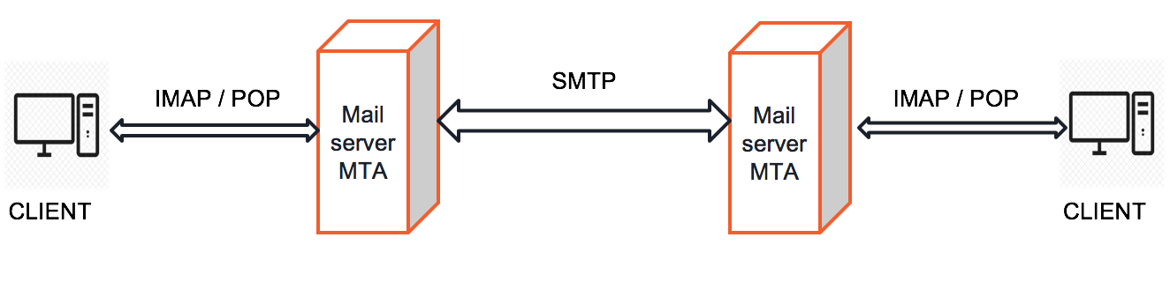
Figure 2.7 Mail Server

A message transfer agent receives mail from either another MTA, a mail submission agent (MSA), or a mail user agent (MUA). The transmission details are specified by the Simple Mail Transfer Protocol (SMTP). When a recipient mailbox of a message is not hosted locally, the message is relayed, that is, forwarded to another 6712MTA. Every time an MTA receives an email message, it adds a Received trace header field to the top of the header of the message, thereby building a sequential record of MTAs handling the message. The process of choosing a target MTA for the next hop is also described in SMTP, but can usually be overridden by configuring the MTA software with specific routes. [9]
2.2.4. FTP Server
The File Transfer Program (FTP) is a standard network protocol used for the transfer of computer files between a client and server on a computer network.
FTP is built on a client-server model architecture separate control and data connections between the client and the server. FTP users may authenticate themselves with a clear-text sign-in protocol, normally in the form of a username and password, but can connect anonymously if the server is configured to allow it. For secure transmission that protects the username and password, and encrypts the content, FTP is often secured with SSL/TLS (FTPS) or replaced with SSH File Transfer Protocol (SFTP).

Figure 2.8 FTP Server

Explicit FTPS is an extension to the FTP standard that allows clients to request FTP sessions to be encrypted. This is done by sending the "AUTH TLS" command. The server has the option of allowing or denying connections that do not request TLS. This protocol extension. Implicit FTPS is an outdated standard for FTP that required the use of a SSL or TLS connection. It was specified to use different ports than plain FTP. [10]
A dedicated network server or software within a network server that enables uploading and downloading files via the FTP protocol.
2.3. Introduction to Server (Device)
All devices included in internet network connect to each other by using IP addresses. Other internet users can also use our computers as internet web server by using IP address if our computers have access to internet line, have also IP address and web server software have already installed in our computers.
Computers in which server programs have installed are called Servers (Devices). Types of servers are house server: placing server devices in our schools or companies and cloud hosting: we don’t need to place server devices like as house server and can easily use servers from providers by online registration via provider’s websites.
A cloud server is a logical server that is built, hosted and delivered through a cloud computing platform over the Internet. Cloud servers possess and exhibit similar capabilities and functionality to a typical server but are accessed remotely from a cloud service provider.
There are many providers of cloud hosting such as amazon AWS, Google AppEngine, DigitalOcean and etc. Among them, DigitalOcean was used and two servers had been registered in DigitalOcean cloud hosting provider. CentOS was run on one server (public IP: 206.189.152.127) as shown in figure and ubuntu on another (public IP: 178.128.111.221) as shown in figure

Figure 2.9 CentOS was run on cloud server (public IP: 206.189.152.127)

Figure 2.10 Ubuntu was run on cloud server (public IP: 167.99.78.5)
2.4. Port Number and Protocol
The Internet Assigned Numbers Authority (IANA) is responsible for the global coordination of the DNS Root, IP addressing, and other Internet protocol resources. This includes the registration of commonly used port numbers for well-known Internet services. The port numbers are divided into three ranges: the well-known ports, the registered ports, and the dynamic or private ports. The requirements for new assignments in range are stricter than for other registrations [11], examples as shown in table 2.4

Port Number | Protocol
20 | FTP Data
21 | FTP Control
22 | SSH
25 | SMTP
587 | SMTP TLS
465 | SMTP SSL
53 | DNS
80 | HTTP
443 | HTTPS
110 | POP3
143 | IMAP4
993 | IMAP SSL
995 | POP3 SSL
3306 | MYSQL
989 | FTPS Data
990 | FTPS Control
Table 2.4 List of Common Port Number and Protocol
The registered ports are those from 1024 through 49151. IANA maintains the official list of well-known and registered ranges. The dynamic or private ports are those from 49152 through 65535. One common use for this range is for ephemeral ports. The range 49152–65535 (2¹⁵ + 2¹⁴ to 2¹⁶ − 1) contains dynamic or private ports that cannot be registered with IANA. This range is used for private or customized services, for temporary purposes, and for automatic allocation of ephemeral ports.
2.5. About DNS Name and DNS Record
The Domain Name System (DNS) is a hierarchical decentralized naming system for computers, services, or other resources connected to the Internet or a private network. It associates various information with domain names assigned to each of the participating entities. Most prominently, it translates more readily memorized domain names to the numerical IP addresses. By providing a worldwide, distributed directory service, the Domain Name System is an essential component of the functionality on the Internet, that has been in use since 1985. [12]

2.5.1. Domain Name
A domain name is an identification string that defines of administrative autonomy, authority or control within the Internet. Domain names are formed by the rules and procedures of the Domain Name System (DNS). Any name registered in the DNS is a domain name. Domain names are used in various networking contexts and for application-specific naming and addressing purposes. In general, a domain name represents an Internet Protocol (IP) resource, such as a personal computer used to access the Internet, a server computer hosting a web site, or the web site itself or any other service communicated via the Internet. In 2018, 395.6 million domain names had been registered. [13]

2.5.1.1. Fully Qualified Domain Name (FQDN)
Figure 1.11 Fully Quality Domain Name (FQDN)
A Fully Qualified Domain Name (FQDN), sometimes also referred to as an absolute domain name, is a domain name that specifies its exact location in the tree hierarchy of the Domain Name System (DNS). It specifies all domain levels, including at least a second-level domain (Host Name) and a top-level domain as shown in figure 5. A fully qualified domain name is distinguished by its lack of ambiguity: it can be interpreted only in one way.

2.5.2. Domain Name Register
Firstly, the name we liked must be chosen to register domain name. However, this name should not include special characters except dash (-). After it have been registered, Top Level Domain (TLD) must be chosen. TLD are .com, xyz, .info, .name, .asia , .net which are extensions of domain name. Refer to figure 5
There are many domain-name service providers at which the domain can be registered such as google domain name service(https://domains.google.com), GoDaddy(https://sg.godaddy.com/) , HostGator(https://www.hostgator.com/domains).

Figure 2.12 GoDaddy’s domain name registration webpage

Among them, the one used in this thesis is GoDaddy(https://sg.godaddy.com/). Two registered names at GoDaddy are “soelapyaehtun.me” to be used together with CentOS and “soelapyaehtun.com” with ubuntu.
2.5.3. DNS Record
DNS records are basically mapping files that tell the DNS server which IP address each domain is associated with, and how to handle requests sent to each domain. When someone visits a web, a request is sent to DNS server and forwarded to the web server provided by a web hosting company, which contain the data contained on the on the site.
Various string of letters is used as commands that dictate the actions of the DNS server and these strings of commands are called DNS syntax. Some DNS records syntax that are commonly used in nearly all DNS record configurations are A, AAAA, CNAME, MX, PTR, NS, SOA, SRV, TXT, and NAPTR. The following table details the meaning and usage of commonly DNS records. [14]

DNS Records | Function
A | Returns a 32-bit IPv4 address, most commonly used to map hostnames to an IP address of the host
AAAA | Returns a 128-bit IPv6 address, most commonly used to map hostnames to an IP address of the host.
CNAME | Alias of one name to another: the DNS lookup will continue by retrying the lookup with the new name
MX | Maps a domain name to a list of message transfer agents for that domain
Table 2.5 Li{t of"commof DnQ0Bebordr type

NS
Delegates a DNS zone to use the given authoritative name servers

TXT
OriginÁnly fgr !rbitrary human-råidaj|m text in a DNS recnrd
'

